CLI

Wsl – windows subsystem for linux
To open-
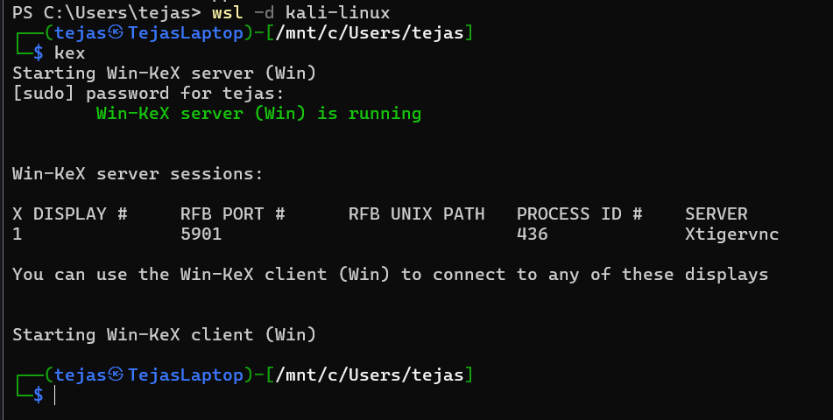

IN LINUX –
1.Directories
pwd = present/print working directory – gives the location of current directory
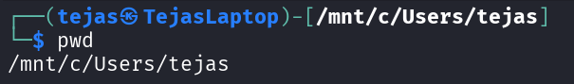
ls = list = lists all the items in current dir
ls <name>/ = lists all the items in <name> dir
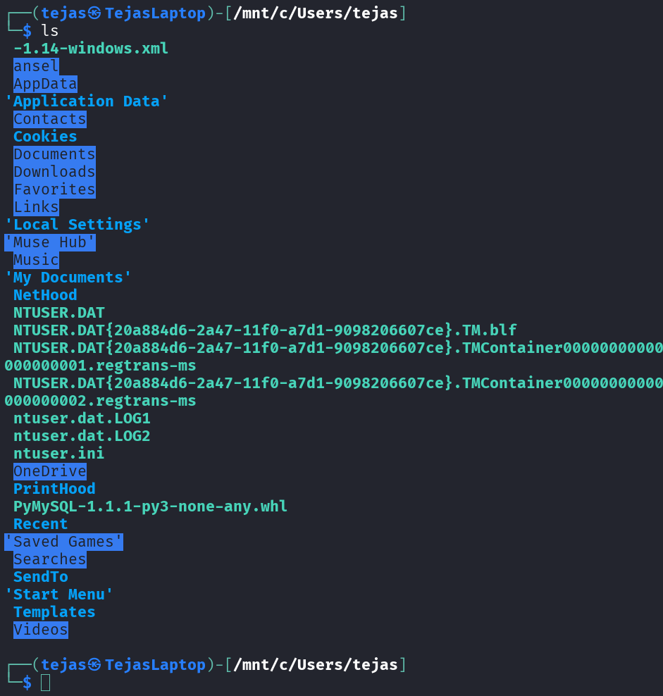

ls -la = -l is long and a is all = detailed listing including hidden folders
* when we use ls -la we see output like
drwxrwxrwx 1 tejas tejas 512 Oct 14 21:17 .
d stands for dir
- Stands for file
rwx – read write exe
after d first 3 letters are perm for owner of file
next 3 if perm for members of group in case of group ownership
last 3 are for common user
cd = change directory = changes directory acc to argument given
cd .. = goes to previous directory
cd <name>/ = goes to <name> dir in current directory
cd ~/<name>/ = goes to <name> dir in home folder (~/)
which <file> = used to determine the loc of file used incase of dupes
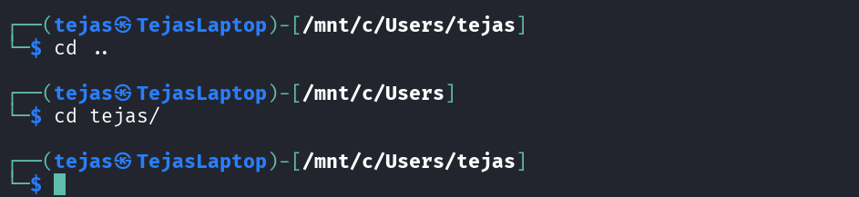
mkdir <name> = make dir – makes a new dir <name> in the current dir
cp -r <dir1> <dir2> = copies <dir1> and all its contents to <dir2>
rmdir <name> = remove dir – removes <name> if empty (safety ft)
rm -r <dir> = deletes dir and -r stands for recursive = deletes a dir and everything inside it

-f or –-force = force = do the cmd no matter what and don’t ask questions and if fails it fails silently

*EVERYTHING IN LINUX IS A FILE*
bin – binaries – contains cmd binaries or files containing code abt a cmd
sbin – super binaries – cmds admin would use

2.Files
echo “<str>” > <filename>.txt = a way to write into a file = echo prints the output <str> on the terminal but by using ‘>’ we can paste the output in <filename>. echo is like print
cp <name> <dir>/ = copies/duplicates a file/dir <name> from current dir and pastes to <dir>
mv <name> <dir>/ = moves a file/dir <name> from current dir and pastes to <dir>
mv <name1> <name2> = standard cmd to rename file <name1> to <name2>
touch <name> = if the file doesn’t exist it creates a new empty file and if it exists it updates its access and mod timestamp
rm <name> = removes a file <name>
nano <filename> = nano is a text editor which uses cmds to edit file
gedit <filename> = proper gui based editing in a text editor like notepad
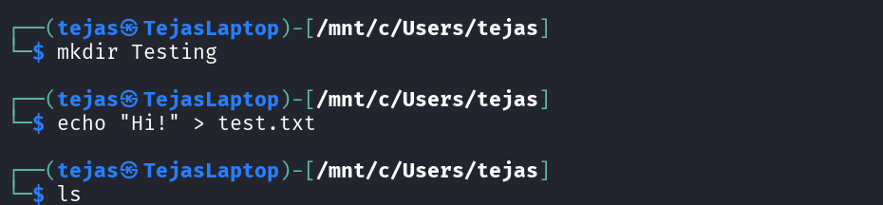
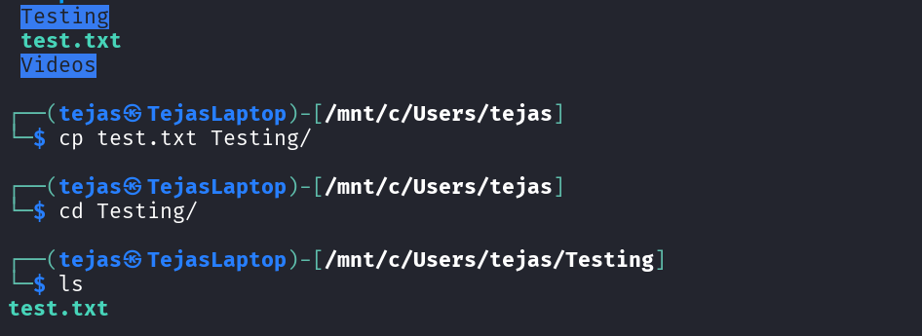
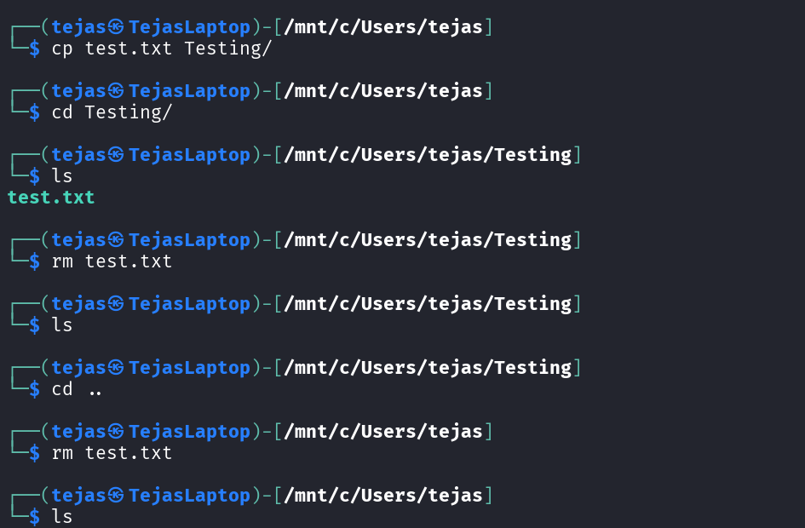
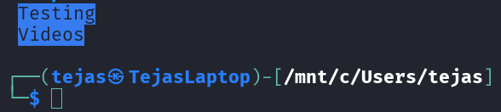

3.Searching and output
find <dir> -name “<file>” = searches inside dir for all files that match <file>
“*” = wildcards = used for patterns = “*.log” = helps in searches
grep “text” <file> = global regular expression print = outputs lines containing “text” and we can use -i for case insensitive
grep -rl "<text>" <dir> = searches all files in dir for “text” and lists only file names cuz of -l
cut -d “<>” -f 4 = it cuts(like python split) the output by -d or delimiter and outputs the -f or field(index starts from 1)
locate <keyword> = locates and lists all files with <keyword>
man <cmd> = gives a manual of cmd
ls –help = some info
cat <name> = concatenate = displays the output of file <name>
less <name> = displays the output in pages format where space is for next pg b is for prev pg and q is to quit reading mode
head <name> = displays first 10 lines
<cmd> > <file> = ‘>’ is output redirection and overwrites the content of file or creates a new file if it doesn’t exist
<cmd> >> <file> = output appending = adds the output of cmd to the very end of the file
<cmd1> | <cmd2> = pipe op = outputs cmd2 with cmd1 as input
clear = clears all outputs from terminal

4.Permissions
– 3 digits -1st owner – 2nd group – 3rd anyone else
Each digit is sum of Read(4), Write(2) and execute(1)
chmod 755 <file> = change mode = sets rwx for owner, rx for group and anyone
chmod -R 600 <dir> = changes perm of <dir> and its contents to rw for owner
chown <user>:<group> <file> = changes the ownership of <file> to <user> of <group>

5.Network and Linux Services
ping <host> = sends small data packets to host(IP or domain) and displays status and response time
whois <domain> = outputs domain registration info
curl -O <url/to/file> = curl is used to transfer data -O is used to save the file in current dir with same filename as url
ssh <username>@host = secure shell establishes an encrypted secure cli connection to remote <host> using <username>
scp <file> <user>@host:/dest = secure copy copies the file to host server using user to dest path
service apache2 start = makes a server at your ip that can be accessed through a web browser
python3 -m http.server <port> = makes a server at your ip at port to display current directory

6.Packages
dpkg = depackage = old
apt = adv pkg tool
aptitude = apt with gui
apt-get update && apt-get upgrade
apt-get install git -y = to install git and answer to every confirmation is yes
git clone <url> = to install using git
apt remove <pkg> = removes app but doesn’t remove user data
apt purge <pkg> = removes everything

7.Processes and Services
* daemon is a program that runs automatically in the background, without any direct user interaction, to manage system-level tasks – always on helper
Systemd (PID = 1)– master daemon controls all other daemons – init system
systemctl – another way to control services
Boot – kernel – Systemd – starts all processes by forking
ps ax = shows processes all(a) including those not attached to terminal(x) and gives their PID
pgrep <ps_name> = ps and grep command combined to return PID
*additional u(user-oriented) flag(ps aux) adds useful headers and columns
top = displays live real time interactive list of running processes
kill <pid> = send termination signal to process telling it to quit
systemctl start <service>
systemctl stop <service>
systemctl status <service>
systemctl restart <service>
systemctl reload <service>
systemctl disabled <service> = disables from starting on boot
systemctl is-active <service> = returns active or inactive
systemctl is-enabled <service>
systemctl list-units = lists all the active daemons
systemctl list-units -t service = -t stands for type = gives list of active daemons controlling Linux services
systemctl

8.Users and Groups
sudo – superuser do – user needs to be in sudoers file
sudo visudo = only way to edit sudoers file
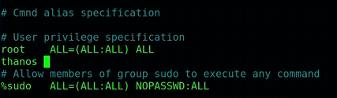
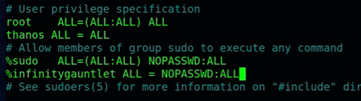
*Sudoers file has a failsafe which prevents you to save the file with errors

adduser john = to add a new user = can only be done by root or using sudo
*Takes inputs and makes everything for the new user
useradd <user> = lazier version of adduser
*can use -m with useradd to create home directory
passwd <usr> = sets password for <usr>

cat /etc/passwd = to get info abt users
*uname:pset:uid:gid:,,,:/home/shell
cat /etc/shadow = displays encrypted passwords
usermod <name> --shell <> = to change default shell of user
usermod -l <new> <old> = to change user name
userdel <usr> = deletes <usr>

groupadd <grpname> = works like adduser but for grp
usermod -aG <grp> <usr> = -a for appending -G for grp addition = adds <usr> to <grp>
gpasswd -d <usr> <grp> = to remove <usr> from <grp>

